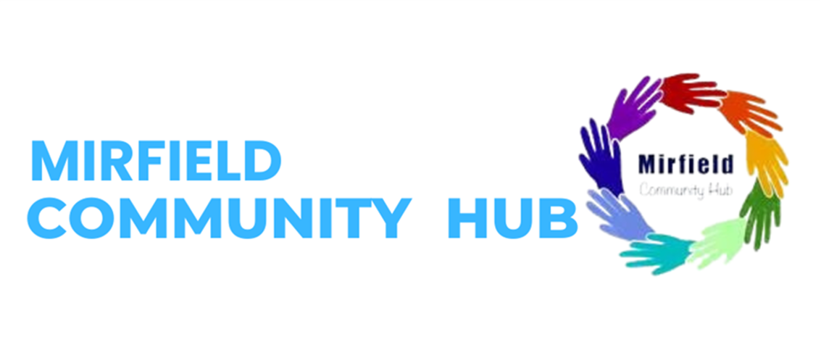

**February Half Term Family Fun event.**

**The Mirfield Community Hub along with Kirklees College and partner agencies are pleased to announce free family fun activity sessions.**

**On: Tuesday 18th February 2025**

**Time: 1:30pm to 3.30pm**

**At: Salvation Army, 106 Huddersfield Rd, WF14 8AF**

Come and join us for free family fun events including:

Spring arts and crafts session with Kirklees college- please bring ID if you would like to participate in this

Lego building, toys for younger children, games.

Uniform available from the Salvation Army

Refreshments provided for children and parents/carers.

For Further information email [claire.nellen@kirklees.gov.uk](mailto:claire.nellen@kirklees.gov.uk)

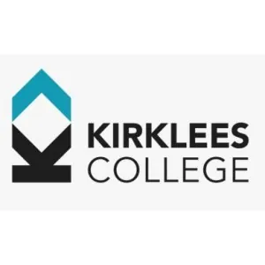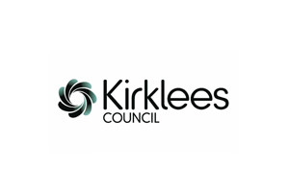

If you wish to take part in the craft activities

Please could you bring the following to enrol with Kirklees College, this ensures that the activities remain free of charge.

You will need to bring the following information with you:

• Proof of address

• National Insurance Number

• Photo ID

• Passport

• Residence Card

• Visa Spouse/Dependent/Joining Family Member - Biometric Residence Permit and passport, partner or family members passport and Biometric Residence Permit, marriage certificate, birth certificate

• Proof of current Asylum status (letter) and ARC card

• Section 95 proof

• Proof of benefits or Access to Universal Credit app on

This ensures that we can offer the course free of charge.